**Object Oriented Programming Lab**

**Fall’20**

**Department of Computer Science**

|  |  |
| --- | --- |
| **STUDENT NAME** | Abdullah Muhammad Ibrahim |
| **STUDENT ID** | SP20-BSCS-0027 |
| **SECTION** | AM |
| **ASSIGNMENT NO.** | 08 |
| **DUE DATE** | 27/12/2020 |
| **SUBMITTED ON** | 23/12/2020 |

***Mohammad Ali Jinnah University***

**Object Oriented Programming Lab**

**Fall’20**

**Question 1/Task 1:**

Create a class named &#39;PrintNumber&#39; to print various numbers of different datatypes

by creating different methods with the same name &#39;printn()&#39; having a parameter for

each datatype.

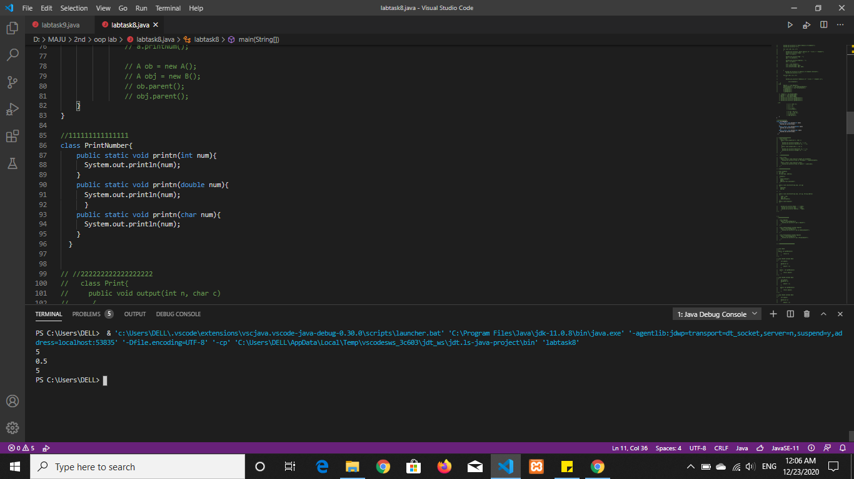

**Question 2/Task 2:**

Create a class to print an integer and a character with two methods having the same

name but different sequence of the integer and the character parameters.

For example, if the parameters of the first method are of the form (int n, char c), then

that of the second method will be of the form (char c, int n).

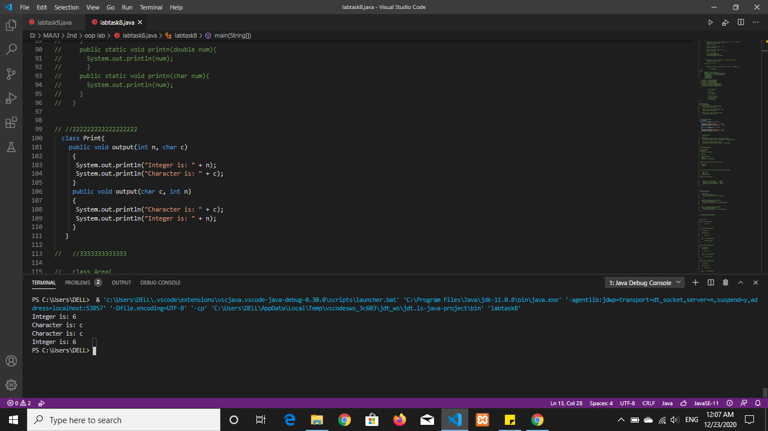

**Question 3/Task 3:**

Create a class to print the ‘area of a square and a rectangle’. The class has two

methods with the same name but different number of parameters. The method for

printing area of rectangle has two parameters which are length and breadth

respectively while the other method for printing area of square has one parameter

which is side of square.

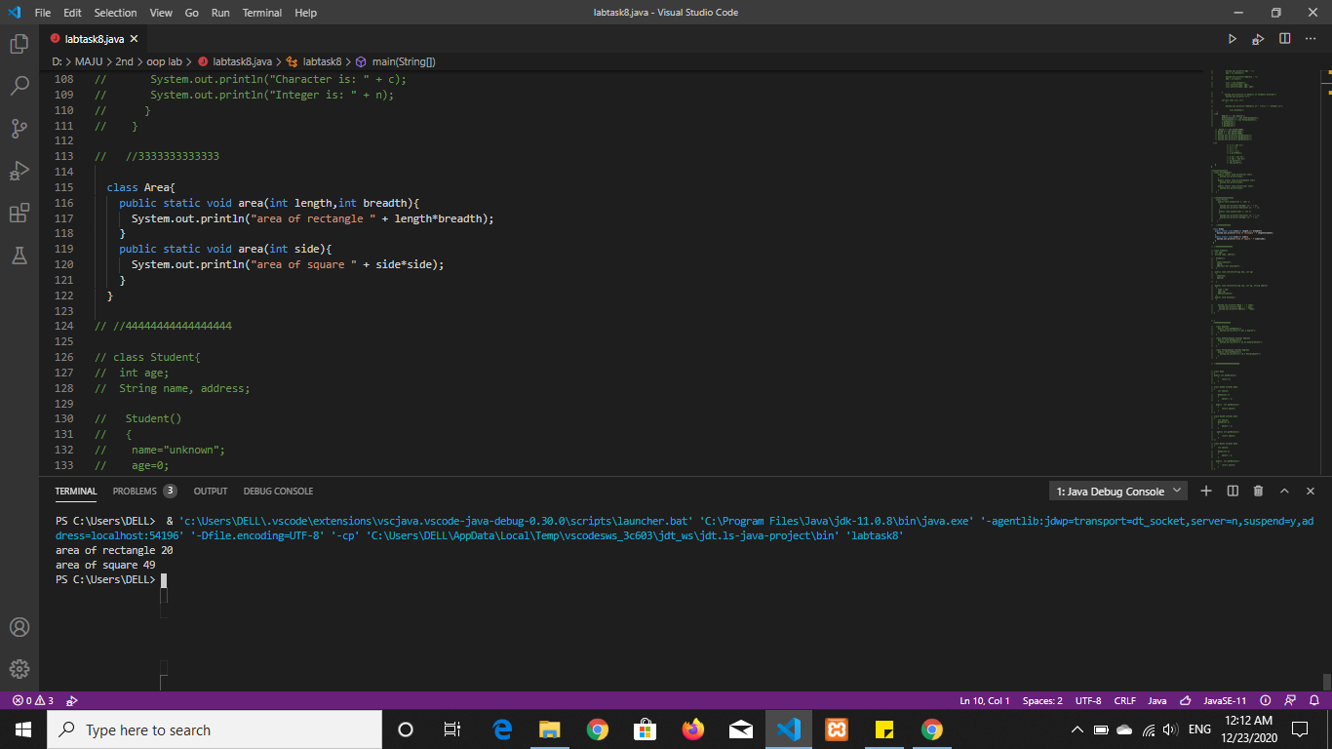

**Question 4/Task 4:**

Create a class &#39;Student&#39; with three data members which are name, age and address.

The constructor of the class assigns default values name as &quot;unknown&quot;, age as &#39;0&#39;

and address as &quot;not available&quot;. It has two members with the same name &#39;setInfo()&#39;.

First method has two parameters for name and age and assigns the same whereas the

second method takes has three parameters which are assigned to name, age and

address respectively.

Print the name, age and address of 5 students.

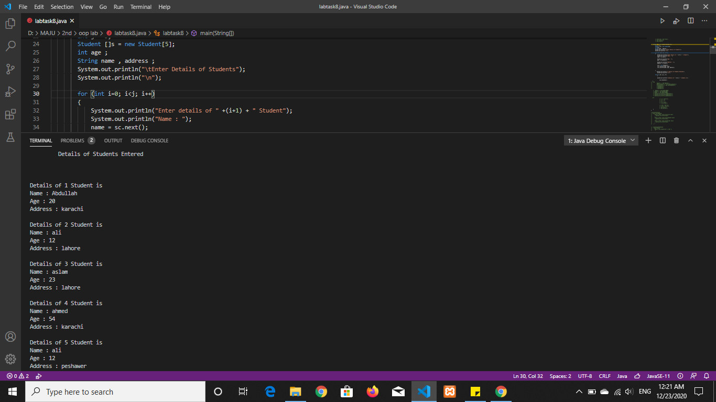

**Question 5/Task 5:**

Create a class &#39;Degree&#39; having a method &#39;getDegree()&#39; that prints &quot;I got a degree&quot;. It has two subclasses namely &#39;Undergraduate&#39; and &#39;Postgraduate&#39; each having a

method with the same name that prints &quot;I am an Undergraduate&quot; and &quot;I am a

Postgraduate&quot; respectively. Call the method by creating an object of each of the

three classes.

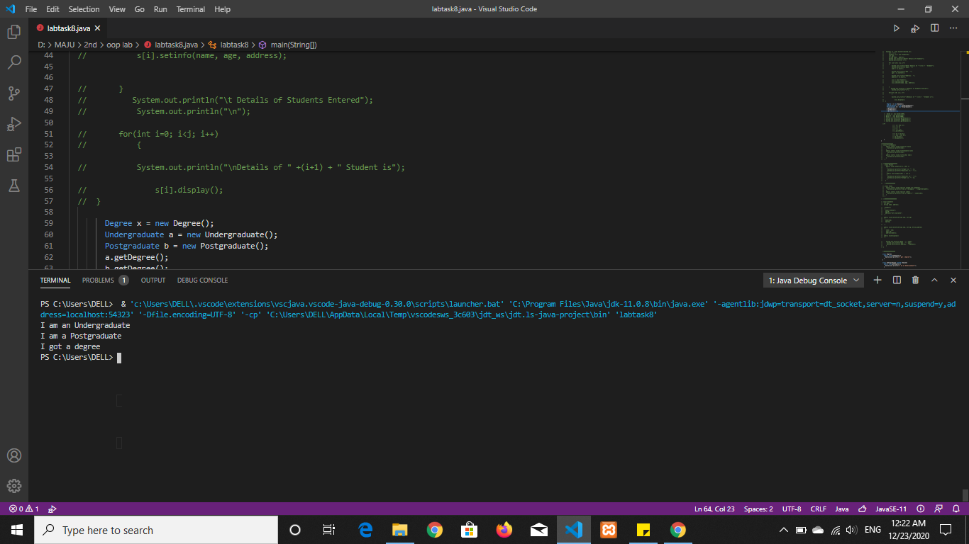

**Question 6/Task 6:**

A boy has his money deposited $1000, $1500 and $2000 in Banks-Bank A, Bank B

and Bank C respectively. We have to print the money deposited by him in a

particular bank.

Create a class &#39;Bank&#39; with a method &#39;getBalance()&#39; which returns 0. Make its three

subclasses named &#39;BankA&#39;, &#39;BankB&#39; and &#39;BankC&#39; with a method with the same

name &#39;getBalance()&#39; which returns the amount deposited in that particular bank. Call

the method &#39;getBalance()&#39; by the object of each of the three banks.

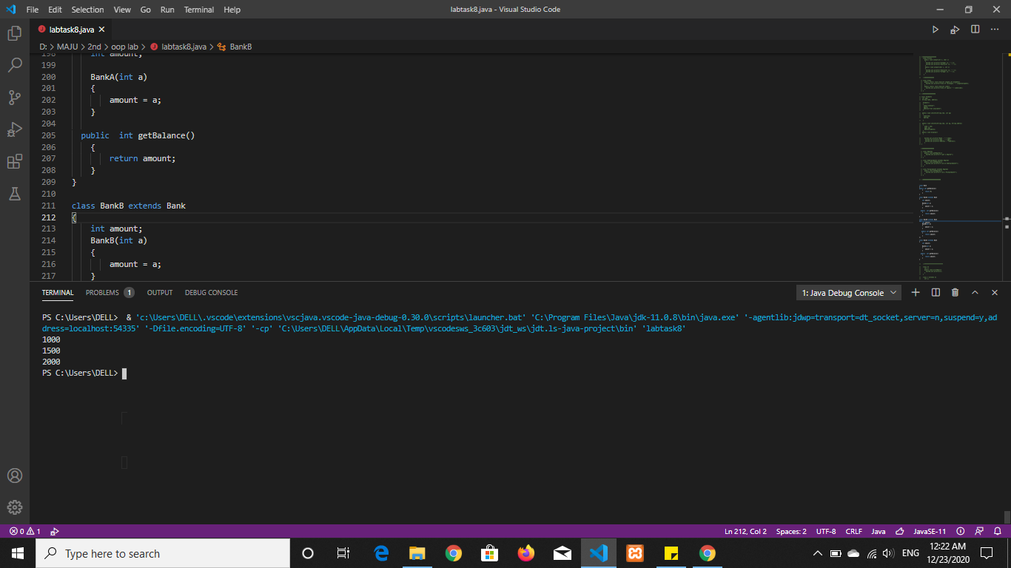

**Question 7/Task 7:**

A class has an integer data member &#39;i&#39; and a method named &#39;printNum()&#39; to print the

value of &#39;i&#39;. Its subclass also has an integer data member &#39;j&#39; and a method named

&#39;printNum()&#39; to print the value of &#39;j&#39;. Make an object of the subclass and use it to

assign a value to &#39;i&#39; and to &#39;j&#39;. Now call the method &#39;printNum()&#39; by this object.

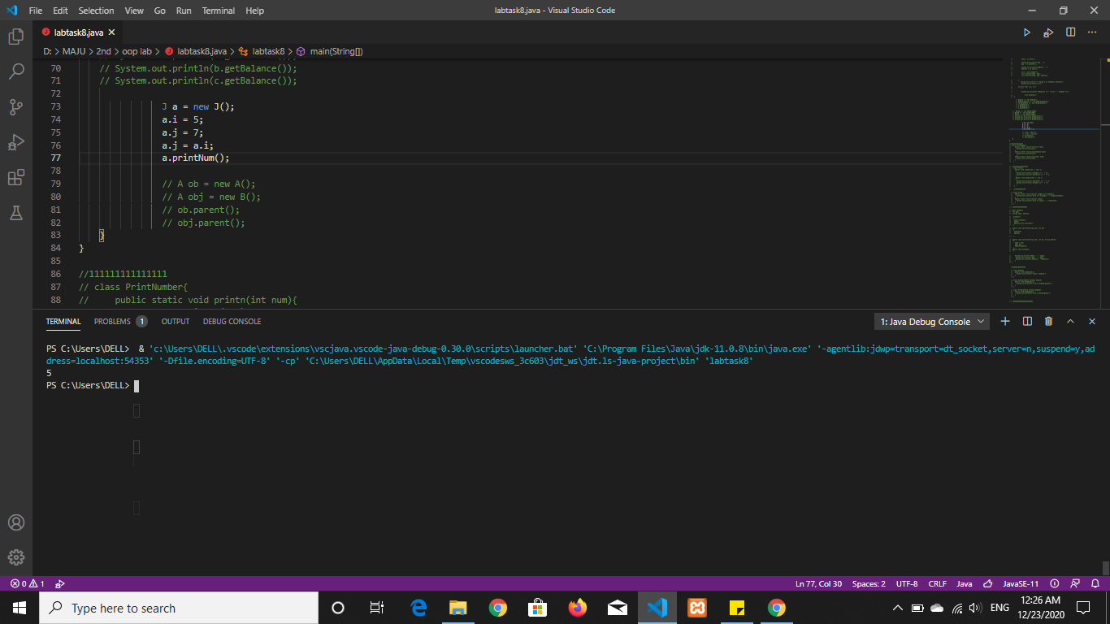

**Question 8/Task 8:**

Suppose a class &#39;A&#39; has a method to print &quot;Parent&quot;. Its subclass &#39;B&#39; also has a method with the same name to print &quot;Child&quot;. Now call this method by the objects of the two

classes. Also, call this method by an object of the parent class referring to the child

class i.e.

A obj = new B();

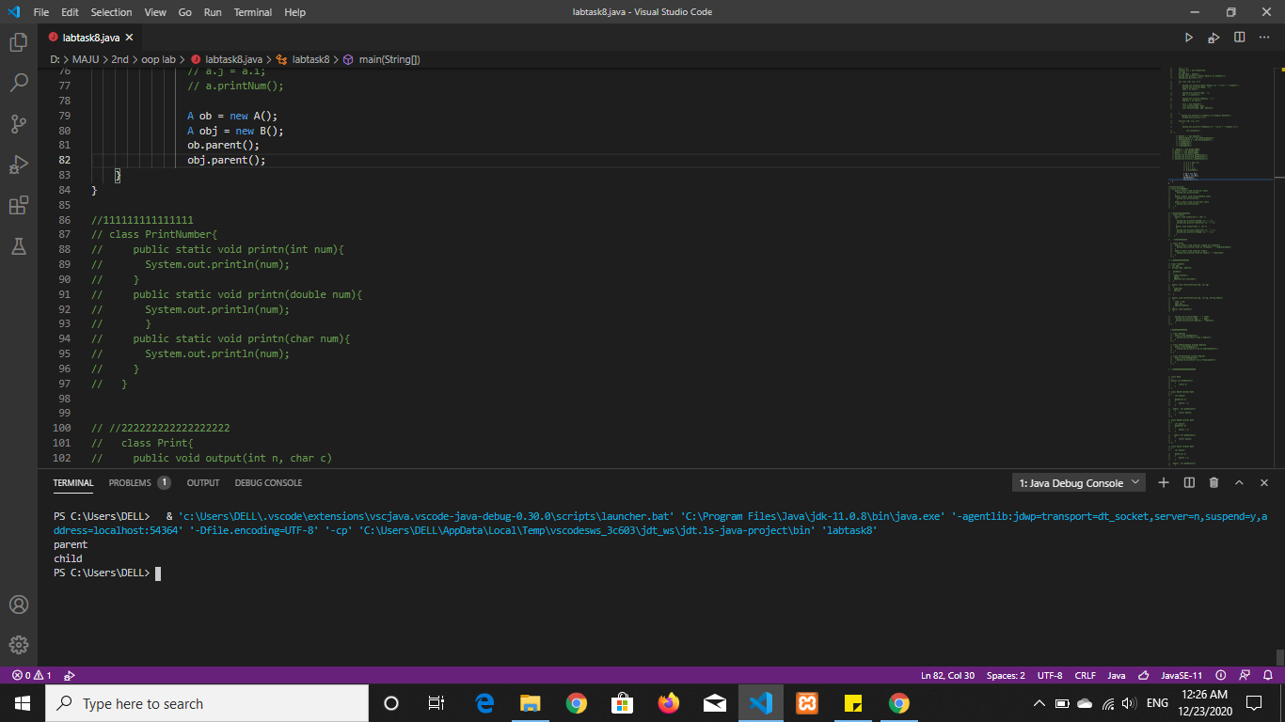

***Mohammad Ali Jinnah University***